Experiment 23:
Aim:
23.Write a Python program to draw a line using given axis values taken from a text file, with suitable label in the x axis, y axis and a title.
Python code:
import matplotlib.pyplot as plt
import numpy as np

# Read axis values from a text file
x, y = np.loadtxt('test.txt', delimiter=',', unpack=True)

# Draw the line
plt.plot(x, y, marker='o', color='g', label='Data from file')

# Add labels and title
plt.xlabel('X-axis Label')
plt.ylabel('Y-axis Label')
plt.title('Line Plot from Text File Data')
plt.legend()

plt.show()
Output:
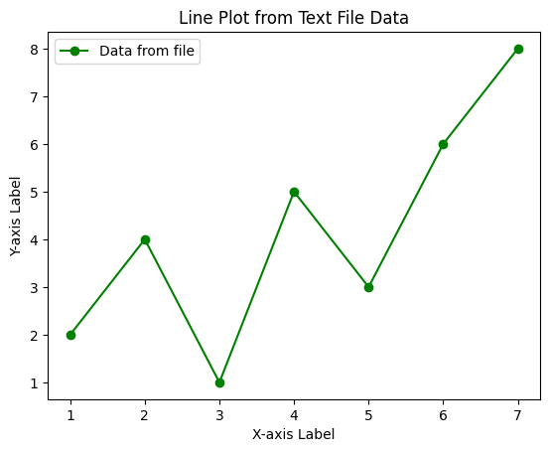
Experiment 24:
Aim:
24.Write a Python program to draw line charts of the financial data.
Python code:
import matplotlib.pyplot as plt
import pandas as pd

# Read the financial data
df = pd.read_csv("financial_data.csv")
print("Financial Data:")
print(df)

# Draw line charts for Open, High, Low, Close
plt.plot(df['Date'], df['Open'], marker='o', label='Open')
plt.plot(df['Date'], df['High'], marker='o', label='High')
plt.plot(df['Date'], df['Low'], marker='o', label='Low')
plt.plot(df['Date'], df['Close'], marker='o', label='Close')

# Add labels and title
plt.xlabel('Date')
plt.ylabel('Stock Price')
plt.title('Financial Data of a Company (Oct 3 - Oct 7, 2016)')
plt.legend()
plt.xticks(rotation=30)
plt.tight_layout()

plt.show()
Output:
